

PROJECT REPORT

**BANKING MANAGEMENT SYSTEM**

**Submitted By:-**

**19070122202 -Yash Verma**

**19070122190 - Pranhav Vanarote**

**19070122195 - Vikash Singh**

SYMBIOSIS INSTITUTE OF TECHNOLOGY

(A CONSTITUENT OF SYMBIOSIS INTERNATIONAL UNIVERSITY)

Pune

2019-2020

**ABSTRACT**

This project is designed for The Bank Staffs to keep the record of their customers. Only authorized Users can have the accessibility to the program. User after Logging in have the support to display all records, and modify it accordingly. If someone is not having Login Id, password he/she could make a new id. Further it can also check overall record of a local customer or full detail of a single a/c as per transactions, create a new record for new customer, Update an old customer record, Delete a record of a customer and Update Loans of the customer.

Python is used as Front End and MySQL is used as Back End.

**INTRODUCTION**

In this project we have used Python and MYSQL . We have created seven(7) frames of Python using Tkinter Package and the widgets are added to it . All the Data of the customers are stored in MYSQL database in tabular form . Thus we can accesses and also update data using connectivity of Python and MYSQL

**FLOWCHART**

**ALGORITHMS**

Step1: START

Step2: ENTER ID AND PASSWORD

Step3: IF NEW USER

THEN CREATE NEW ID PASSWORD USING ATM PIN, THEN GO TO STEP 2

Step4: IF LOGGED IN ,THEN SELECT FROM OPTIONS

1. CREATE A NEW RECORD
2. UPDATE TRANSACTION OF RECORD
3. DELETE RECORD
4. CHECK TRANNSACTION OF RECORD

Step5: IF SELECTED 1 ,THEN ENTER NAME , ACCOUNT NO ,ADDRESS , FIRST DEPOSIT AND SELECT BRANCH AND DATE . IF ENTERED ANY INPUTS WRONG THEN WILL GET THE ERROR ACCORDINGLY

Step6: IF SELECTED 2 ,THEN ENTER NAME , ACCOUNT NO, AMOUNT AND SELECT TRANSACTION TYPE,BRANCH,DATE. IF ENTERED ANY INPUTS WRONG THEN WILL GET THE ERROR ACCORDINGLY

Step7: IF SELECTED 3 ,THEN ENTER NAME , ACCOUNT NO . IF ENTERED ANY INPUTS WRONG THEN WILL GET THE ERROR ACCORDINGLY

Step8: IF SELECTED 4 ,THEN ENTER ACCOUNT NO AND ALL TRANSACTION WILL BE DISPLAYED. IF ENTERED ANY INPUTS WRONG THEN WILL GET THE ERROR ACCORDINGLY

Step9:END

**Python Codes:**

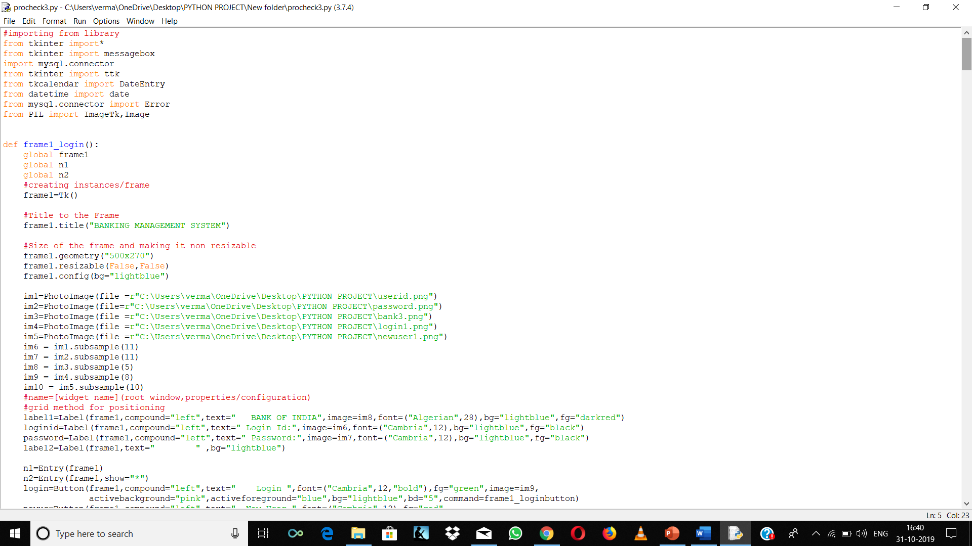

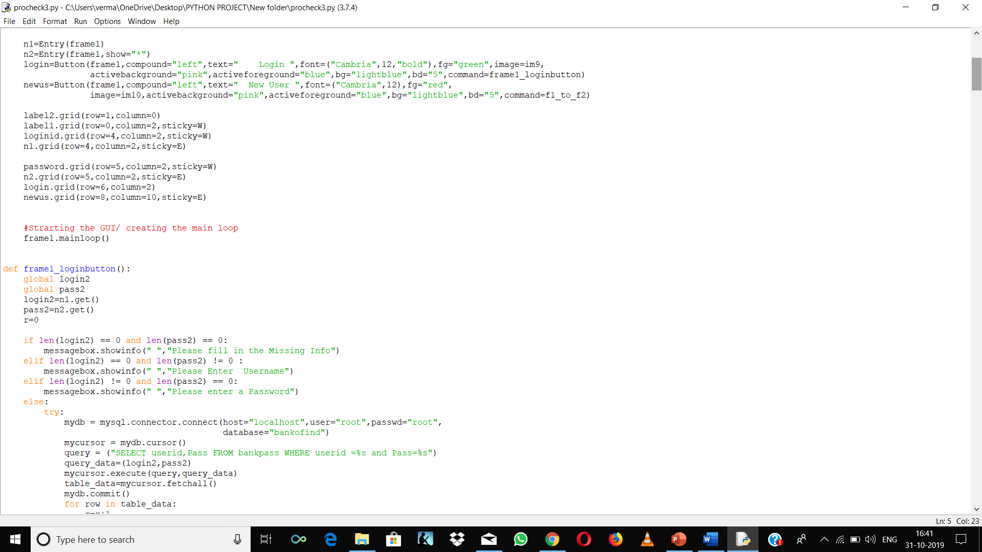

**MYSQL Codes:**

create database bankofind;

use bankofind;

create table bankpass(userid varchar(15) NOT NULL,

Pass varchar(15) NOT NULL,

Atmpin integer(6) Primary Key);

create table bankdata(Name varchar(30) not null,

Acc_no integer primary key,

Branch varchar(30),

Acopen_date date,

Address varchar(100),

Debit integer(20),

Credit integer(20));

create table bankdataac(Name varchar(30) NOT NULL ,

Acc_no integer,

Debit integer(20),

Debitdate date,

DPlace varchar(30),

credit integer(20),

creditdate date,

CPlace varchar(30),

FOREIGN KEY (Acc_no) REFERENCES bankdata(Acc_no));

**Frames Screenshots:**

